**Hands on Exercise**

In this Hands-On Practice you will configure a navigation menu that is interactive and displays a drop down menu. [**Figure 11.16**](https://jigsaw.vitalsource.com/books/9780133971026/epub/OPS/xhtml/fileP7000495062000000000000000003B08.xhtml#P7000495062000000000000000003B0F) displays a site map for the website. Notice how the Cuisine page has three subpages: ­Breakfast, Lunch, and Dinner. You will configure a drop down menu that displays when a visitor hovers over the Cuisine ­navigation hyperlink as shown in [**Figure 11.17**](https://jigsaw.vitalsource.com/books/9780133971026/epub/OPS/xhtml/fileP7000495062000000000000000003B08.xhtml#P7000495062000000000000000003B13).

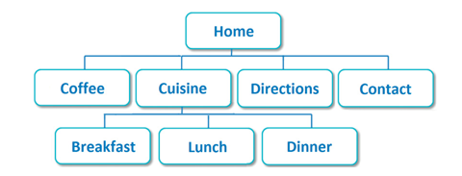

**Figure 11.16  *Site map*.**

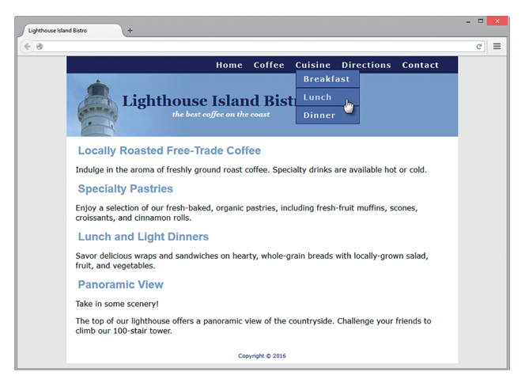

**Figure 11.17  The dropdown menu displays.**

Create a folder named mybistro. Copy the files from the chapter11/bistro folder in the student files into your ­mybistro folder. Notice the main menu has hyperlinks for Home, Coffee, Cuisine, ­Directions, and Contact. You will edit the CSS and edit each page to configure a Cuisine submenu that ­provides hyperlinks to three pages (Breakfast, Lunch, and Dinner).

*Task 1: Configure the HTML.*

Launch a text editor and open the index.html file. You will modify the nav area to contain a new unordered list with hyperlinks to the Breakfast, Lunch, and Dinner pages. You will ­configure a new ul element that is contained *within* the Cuisine li element. The new ul ­element will contain an li element for each room. The HTML follows with the new code ­displayed in blue.

<nav>

<ul>

 <li><a href="index.html">Home</a></li>

 <li><a href="coffee.html">Coffee</a></li>

 <li><a href="cuisine.html">Cuisine</a>

  <ul>

   <li><a href="breakfast.html">Breakfast</a></li>

   <li><a href="lunch.html">Lunch</a></li>

   <li><a href="dinner.html">Dinner</a></li>

  </ul>

 </li>

 <li><a href="directions.html">Directions</a></li>

 <li><a href="contact.html">Contact</a></li>

</ul>

</nav>

Save the file and display it in a browser. Don’t worry if the navigation area seems a bit ­garbled—you’ll configure the submenu CSS in Step 2. Next, edit the nav area in each page (coffee.html, cuisine.html, breakfast.html, lunch.html, dinner.html, directions.html, and contact.html) as you did in the index.html file.

*Task 2: Configure the CSS.*

Launch a text editor and open the bistro.css file.

1. Configure the submenu with absolute positioning. Recall from [**Chapter 7**](https://jigsaw.vitalsource.com/books/9780133971026/epub/OPS/xhtml/fileP7000495062000000000000000001FDE.xhtml#P7000495062000000000000000001FDE) that absolute positioning precisely specifies the location of an element outside of normal flow in relation to its first ­parent nonstatic element. The nav element’s position is static by default so add the following declaration to the styles for the nav element selector:position: relative;
2. The submenu that displays the hyperlinks for the Breakfast, Lunch, and Dinner pages is configured using a new ul element that is contained within the existing ul element in the nav area. Configure a descendent nav ul ul selector and code style declarations to use absolute positioning, #5564A0 background color, 0 padding, left text alignment, and display set to none. The CSS follows:

nav ul ul { position: absolute; background-color: #5564A0;

padding: 0; text-align: left; display: none; }

1. To style each li element within the submenu, use a descendent nav ul ul li selector and configure the li elements in the submenu with a border, block display, 7em width, 1em left padding, and 0 left margin. The CSS follows:

nav ul ul li { border: 1px solid #00005D;

display: block; width: 7em;

padding-left: 1em; margin-left: 0; }

1. Configure the submenu ul to display when the :hover is triggered for the li elements in the nav area. The CSS follows:

nav li:hover ul { display: block; }

Test your pages in a browser.